**Req: Cascade Dropdown values for City Property based on Value selected under State Property.**

**- City should be populated from Cities Table**

**- City should be filtered based on State Value selected.**

**Make Changes to Customer section, Update City Property to Dropdown Control:**

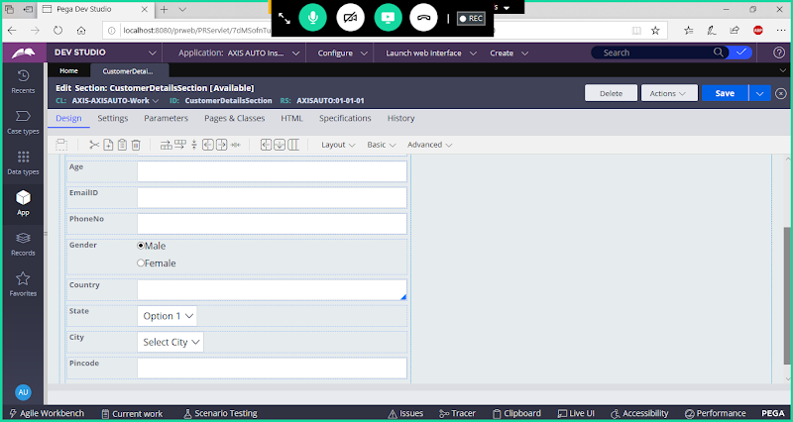

**Open City Property & Remove Static Records ( Set Table Type as None)**

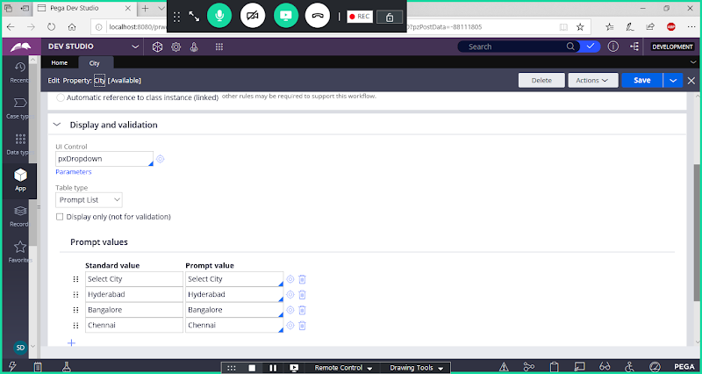

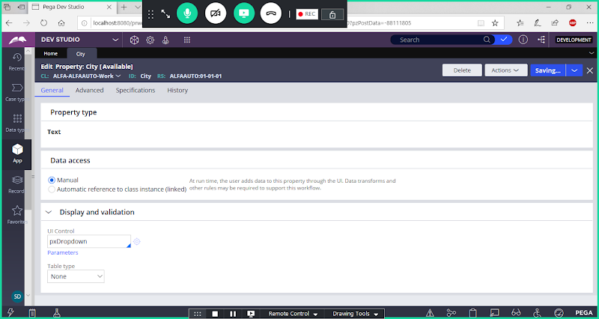

**Save City Property**

**Create a table for adding Cities:**

**Create table from Data Types Explorer:**

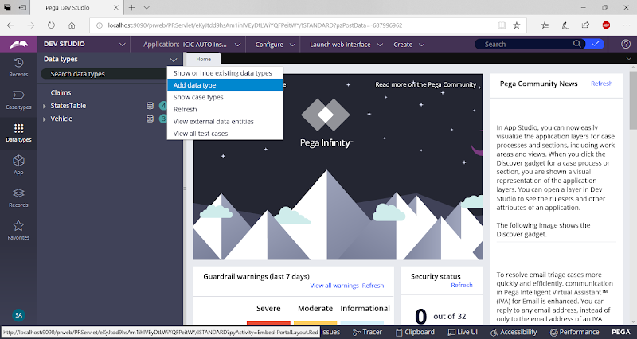

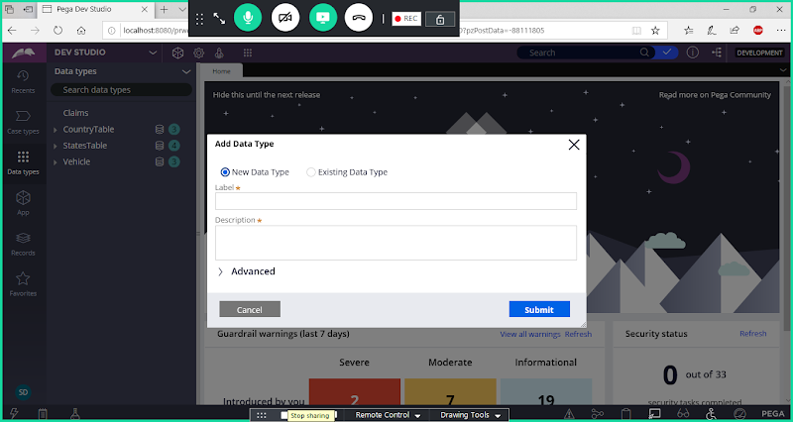

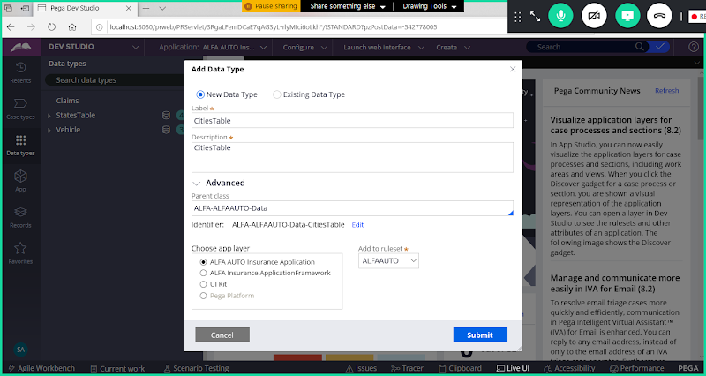

**Change Parent Class to Organization Data Class;**

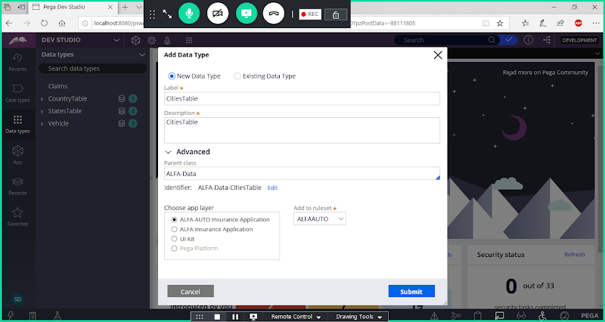

**Submit**

**Add Fields:**

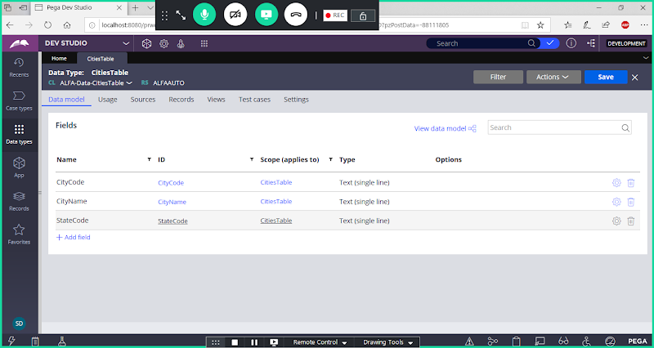

**Add Class Key, Go to Records Tab**

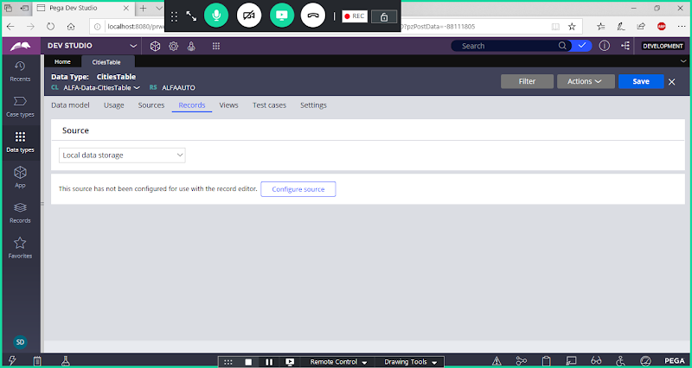

**Configure Source**

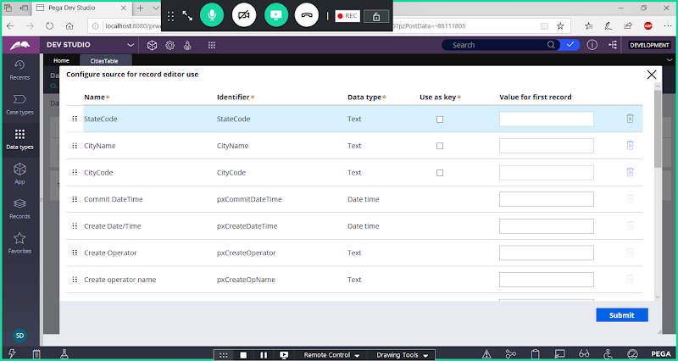

**Set City Code as Class key**

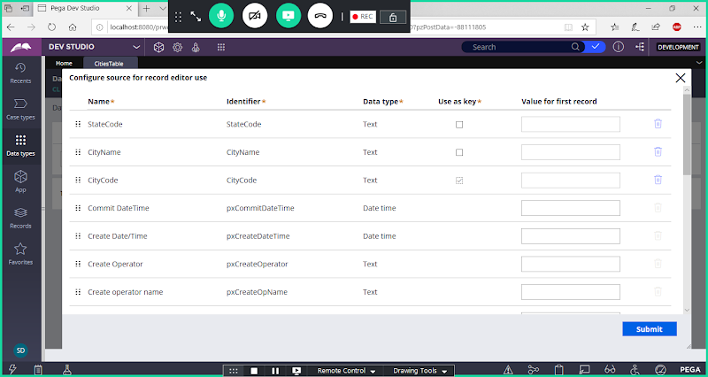

**Submit**

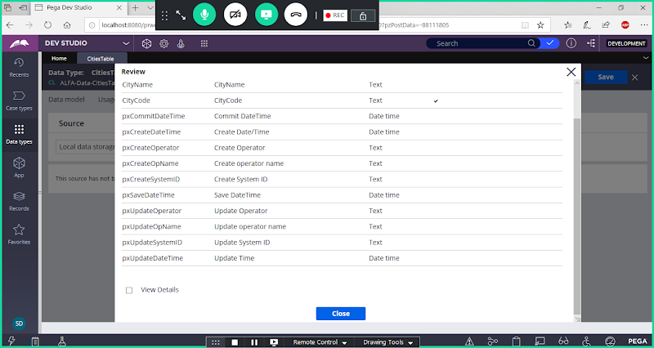

**Close**

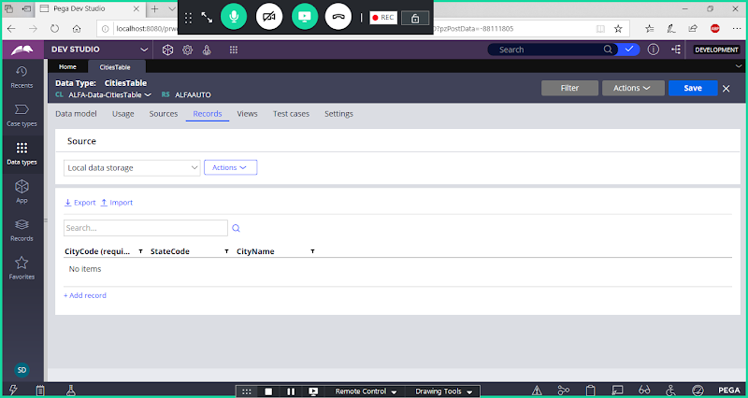

**Edit Columns from Actions Dropdown**

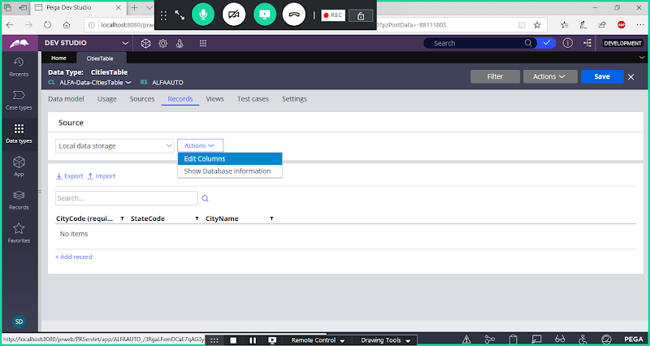

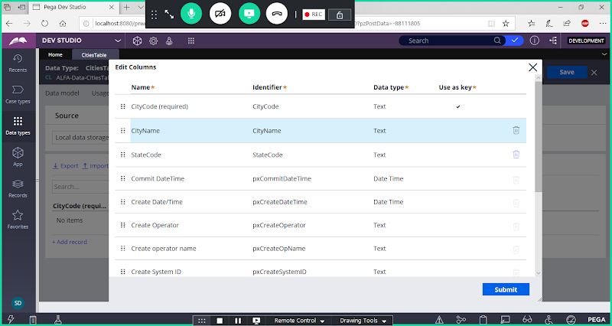

**Submit**

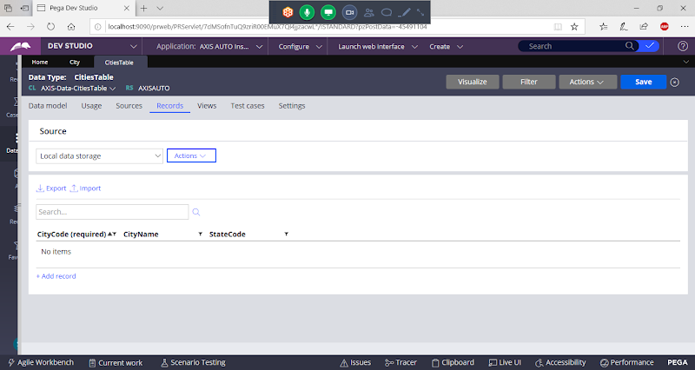

**Add Records Manually**

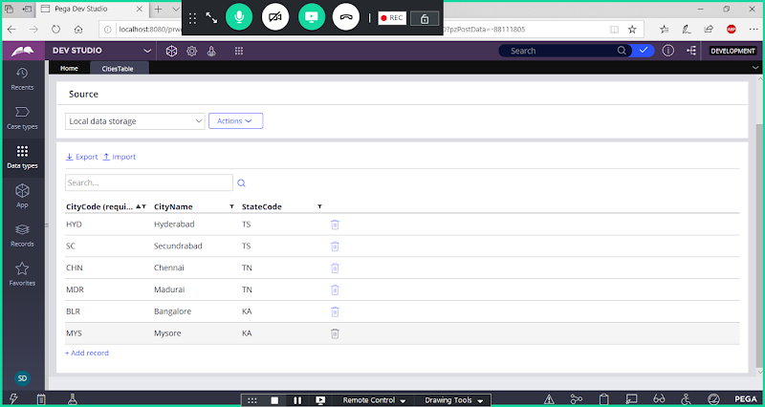

**Pin Data Class to Pinned Classes/PIN Cities Table Data Class to Pinned Classes:**

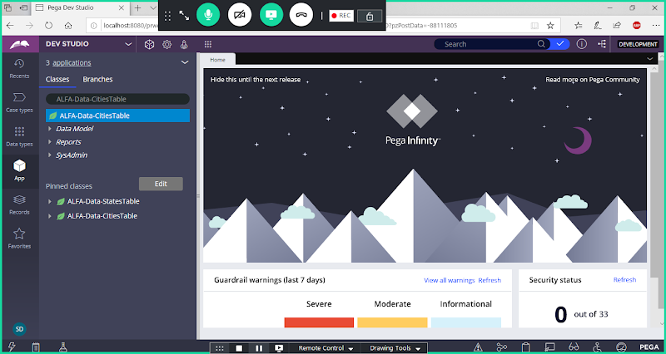

**Cascade Drop Values for City Property Using Report Definition: When State Value is Selected City Values will be filtered based on State Name**

**Create Report Definition under Cities Table**

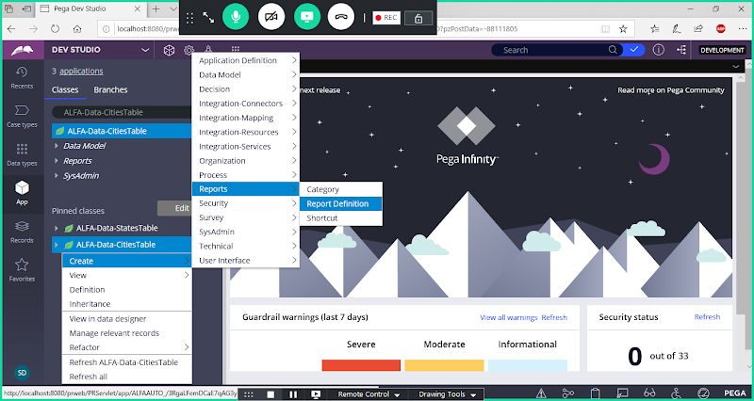

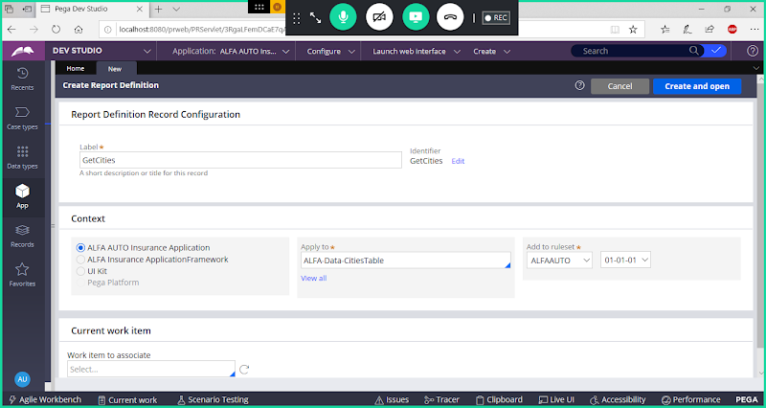

**Open & Go to Parameters Tab -> Add Parameter Name & Type**

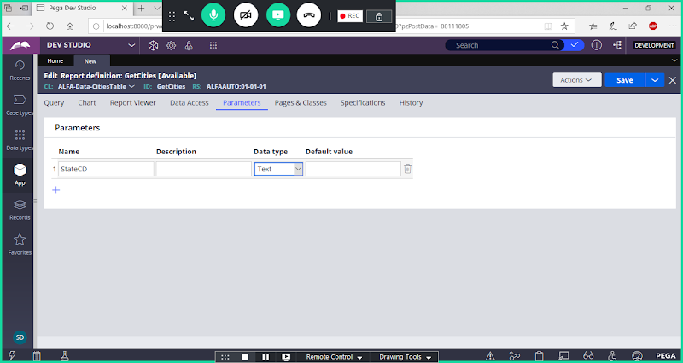

**Go to Query Tab:**

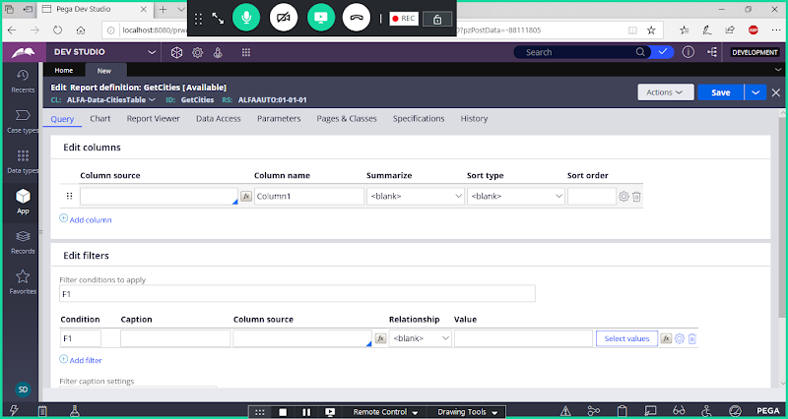

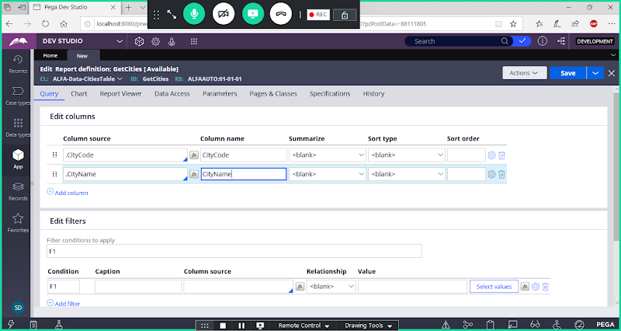

**Add Where Condition**

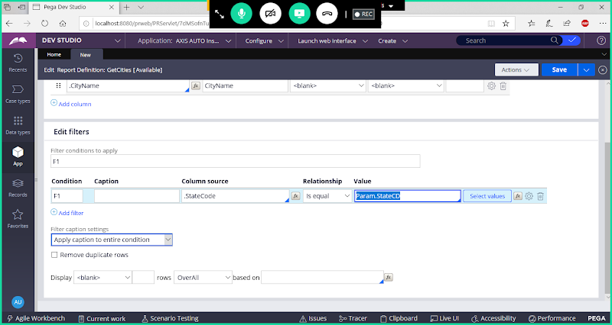

**Open F1 Settings**

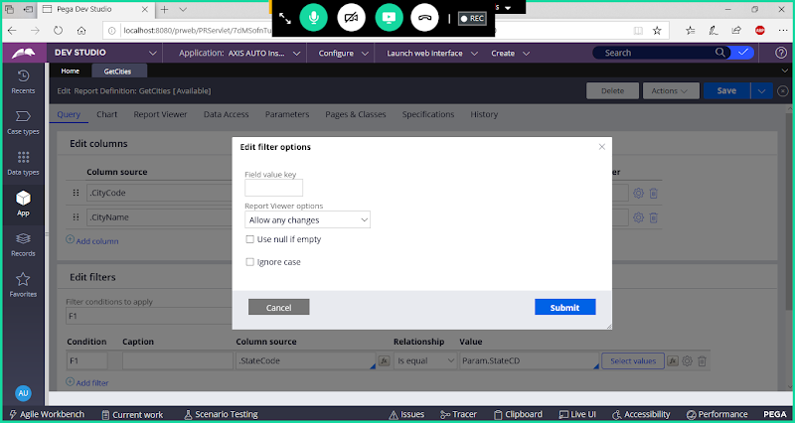

**Enable Use Null if Empty**

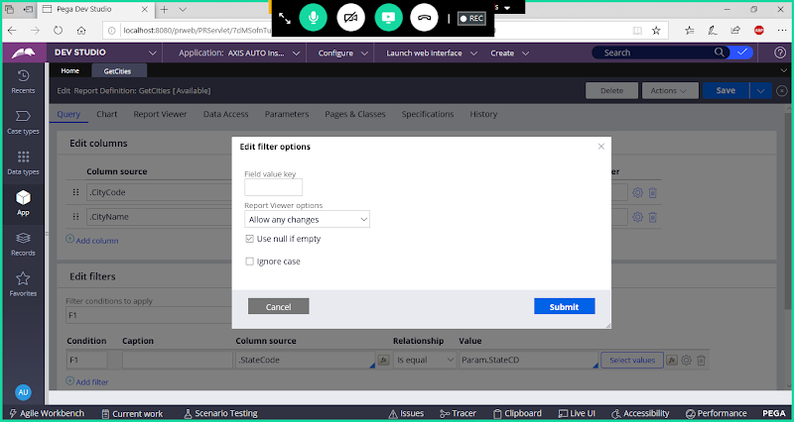

**Submit**

**Save Report**

**Run Report:**

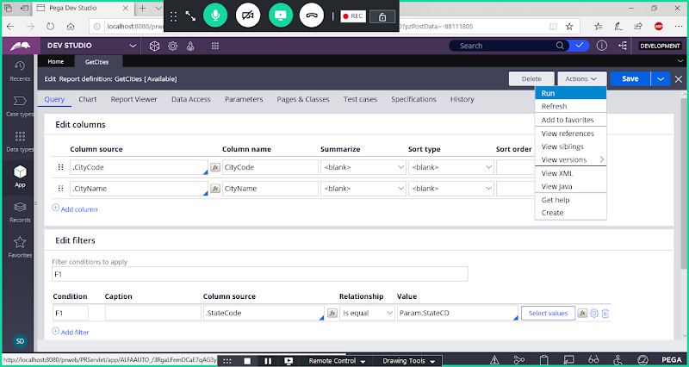

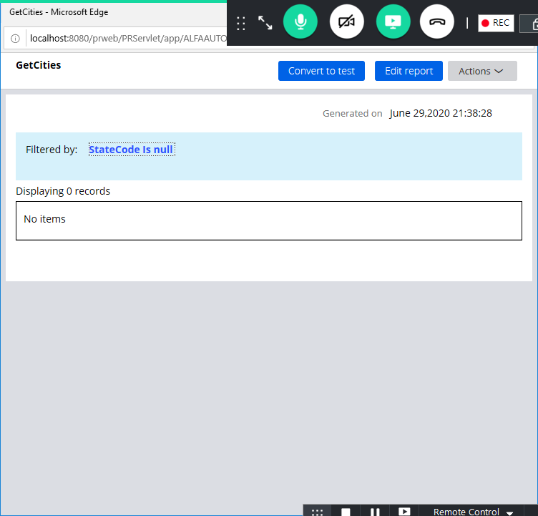

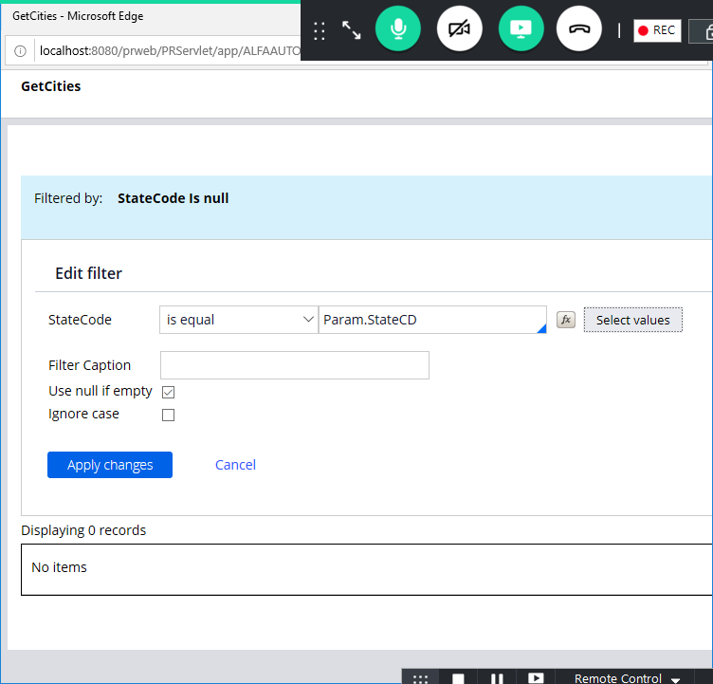

**Select Any Value for State Code -**

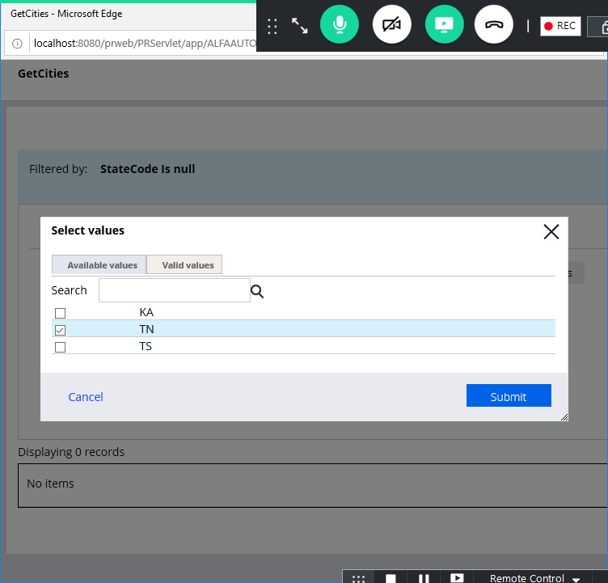

**Submit & Click on Apply Changes**

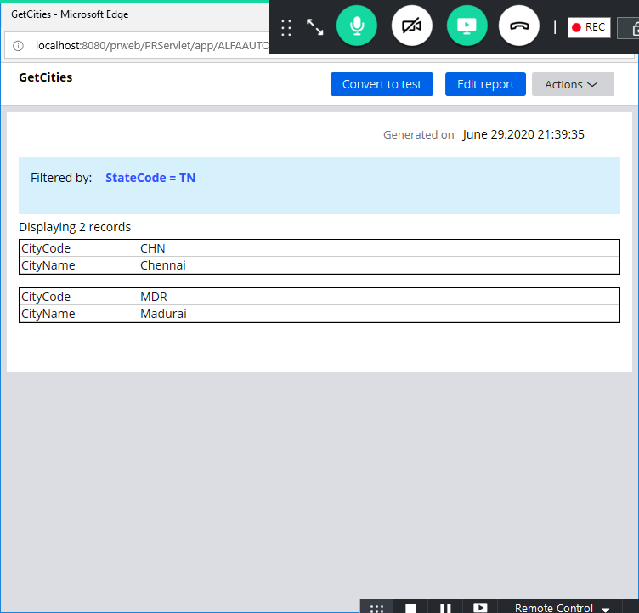

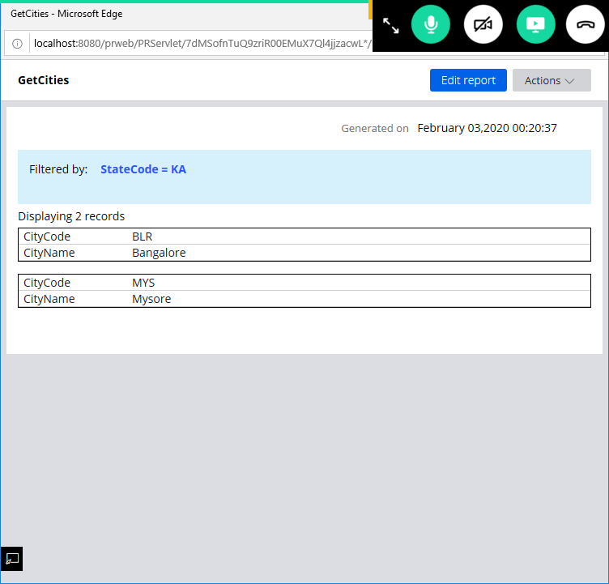

**Now Call Report Definition in Customer Details section for City Dropdown**

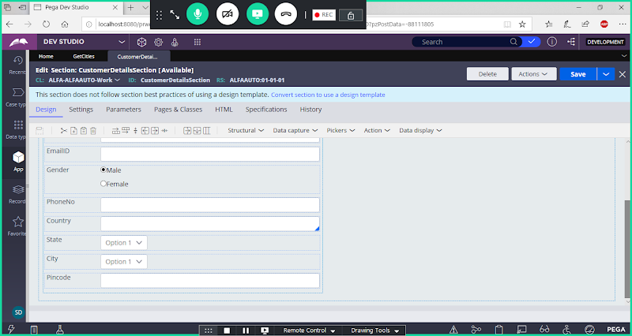

**Double Click on City**

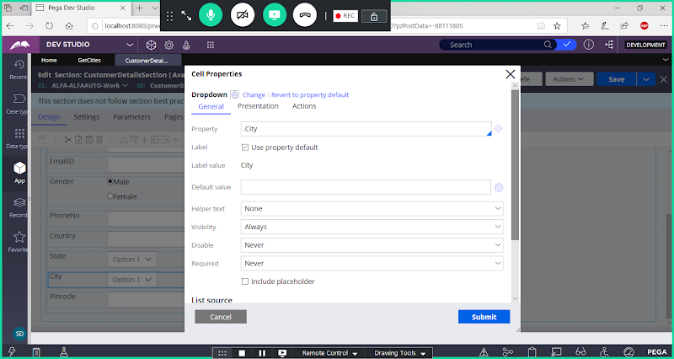

**Add Caption: Select City ( From Include Place Holder Option)**

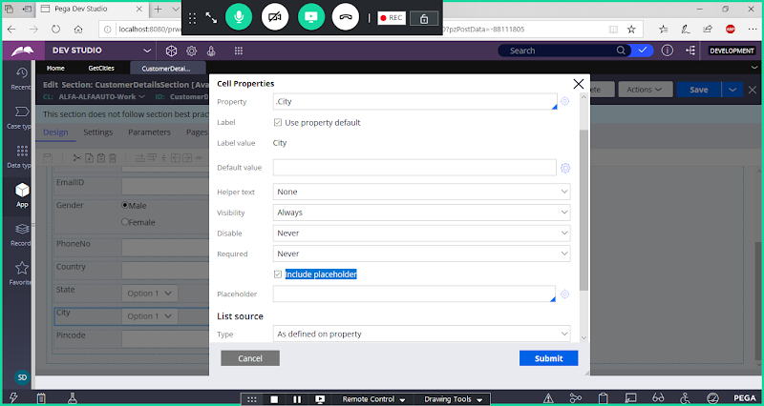

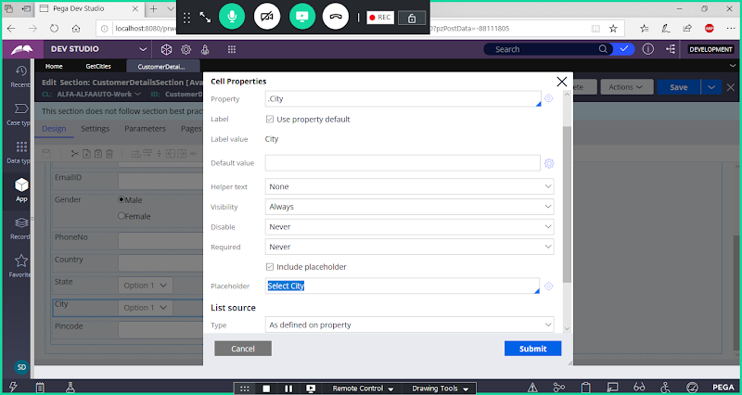

**Select Report Definition**

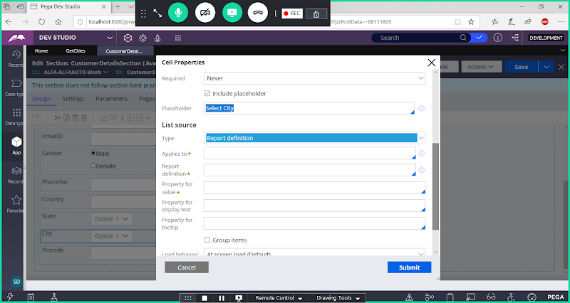

**Now Add Cities Table & Report Definition Rule Name**

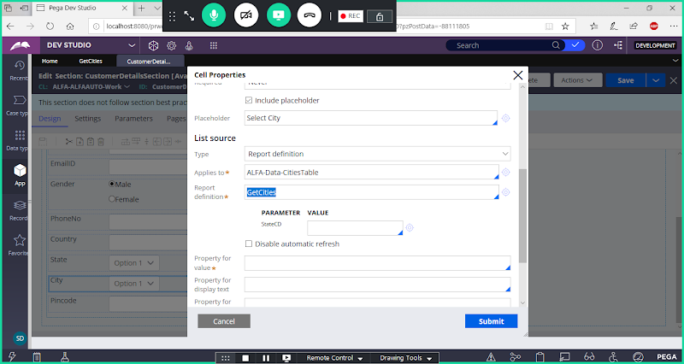

**Now Give Parameter Value ( State Property)**

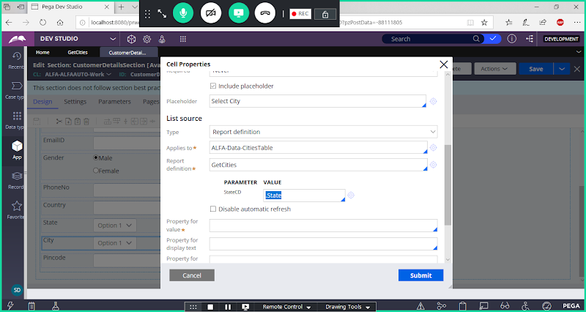

**Add Property  For Value & Property for Display Text**

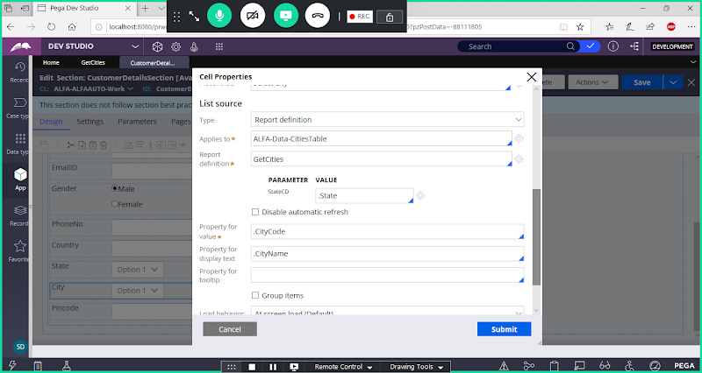

**Submit**

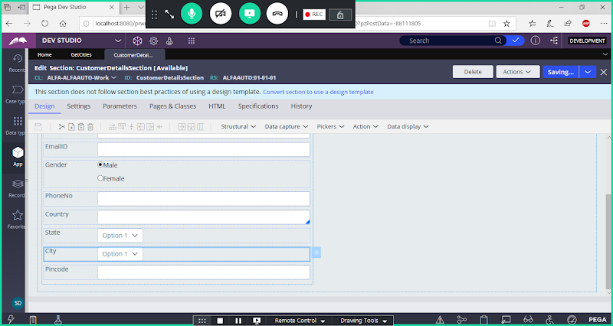

**Save Section**

**Run Customer Flow & Verify:**

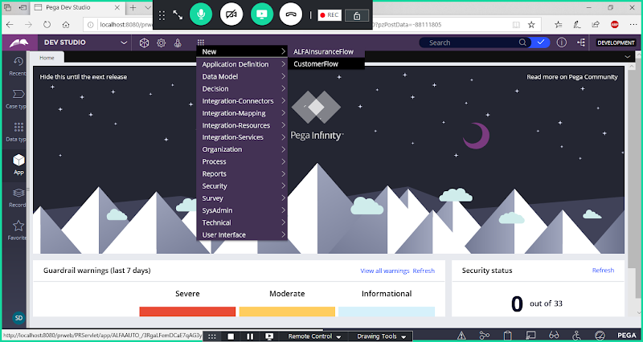

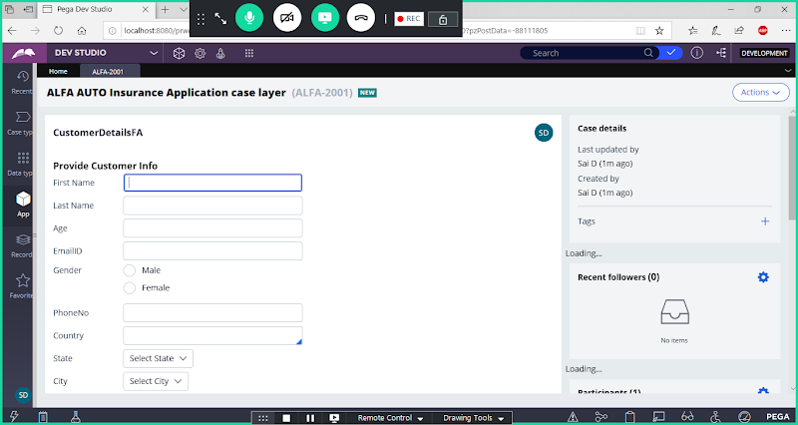

**Select Any State**

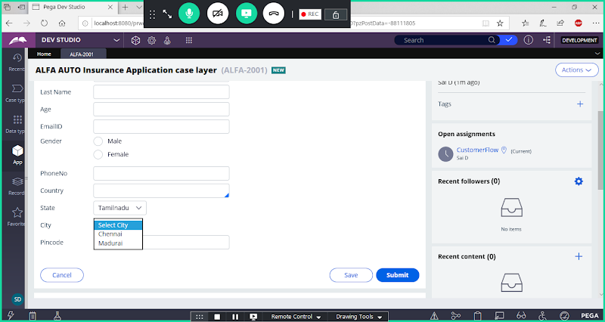

**Cascade City Values based on State Name Using Data Page as Source: Use Existing Report Definition Rule for Loading Values from City Table:**

**Create a Data Page Rule under Cities Table Class:**

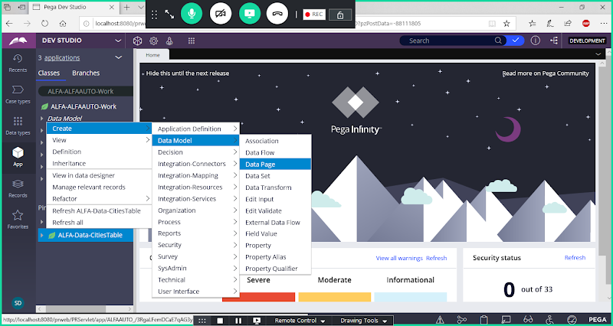

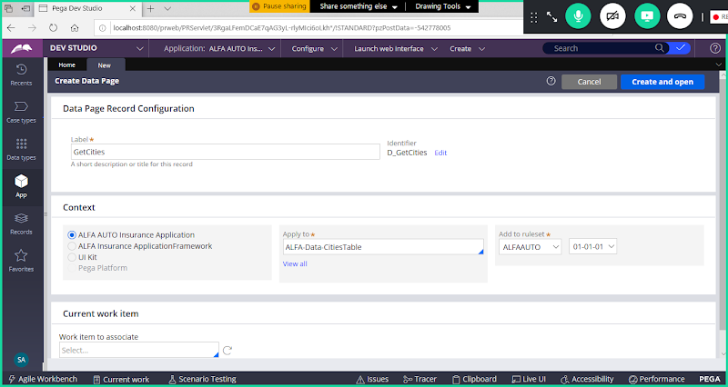

**Open**

**Go to Parameters Tab:**

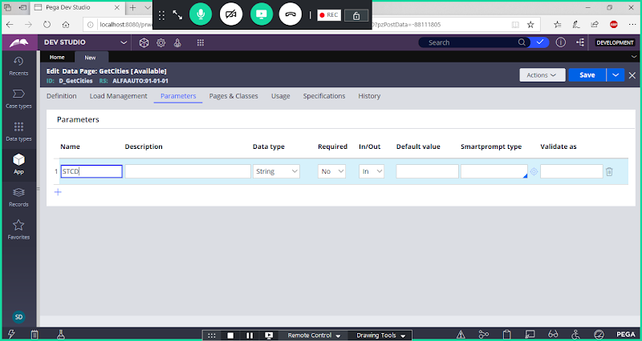

**Go to Definition Tab:**

**Change Structure**

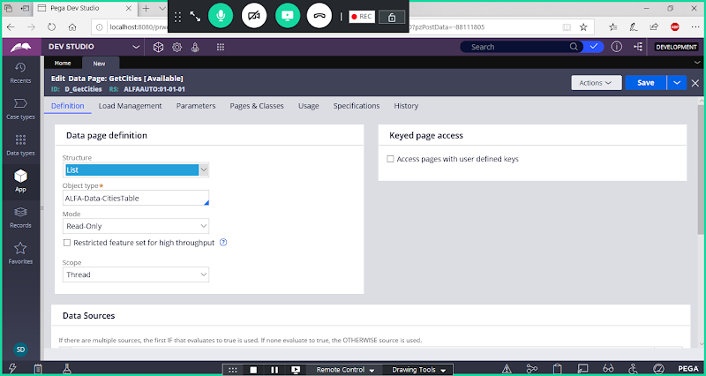

**Add Source:**

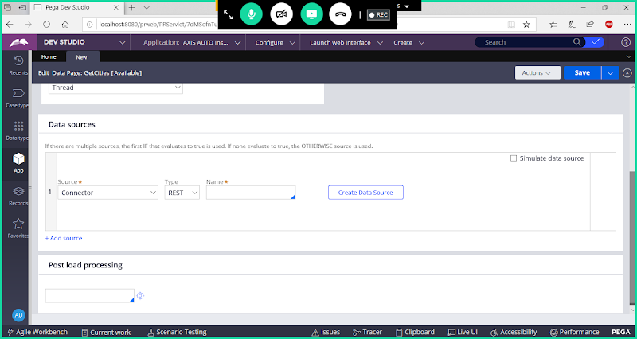

**Select Report  Definition as Source & Add Report Definition Rule Name**

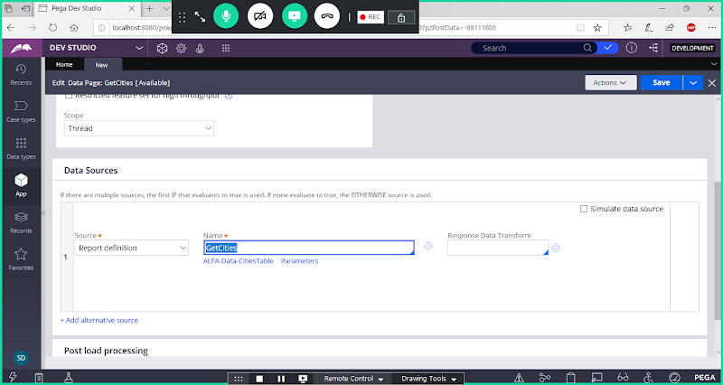

**Click on Parameters Link below Report Definition Name:**

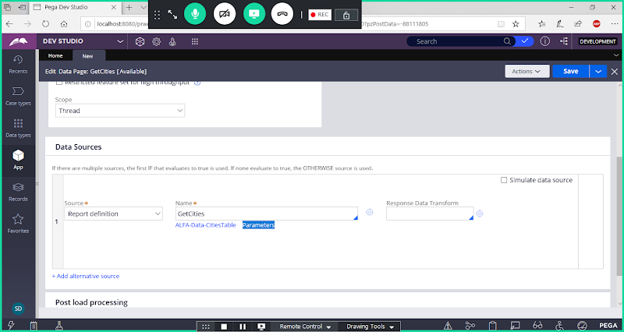

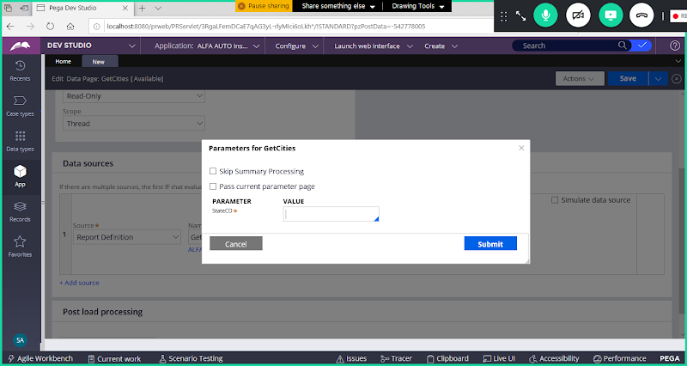

**Now Assign New Parameter Value to the old parameter Value:**

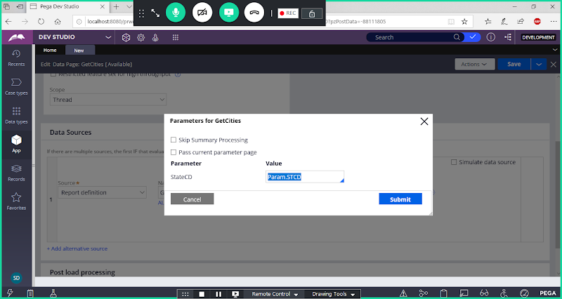

**Submit**

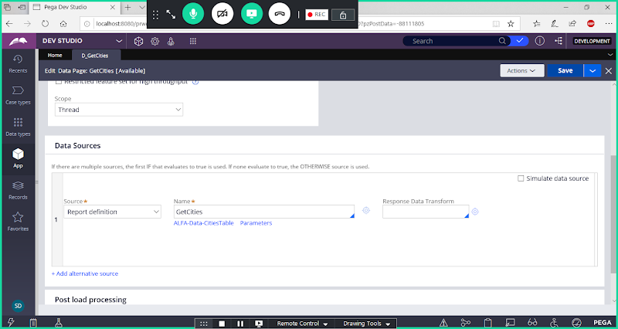

**Save Data Page**

**Now Open Customer section:**

**Map Data Page in City Property Settings:   -> Select Data Page as Source:**

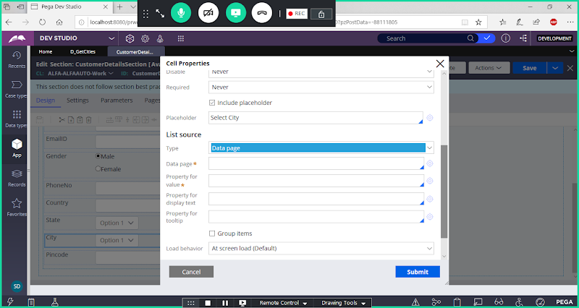

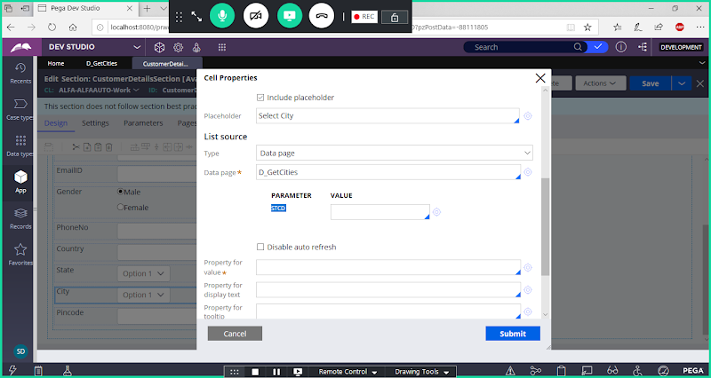

**Give Value as State**

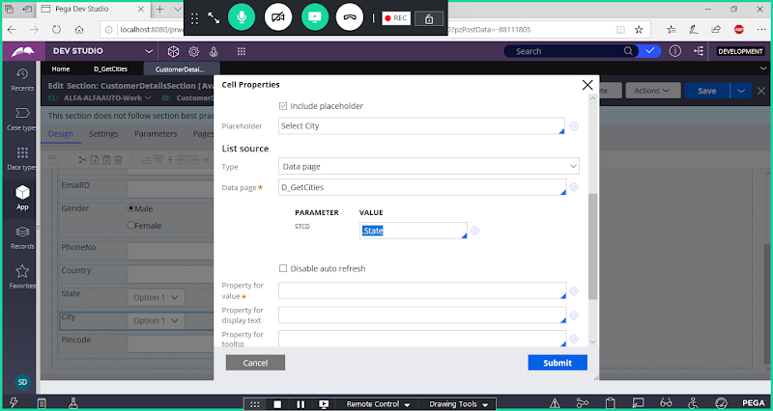

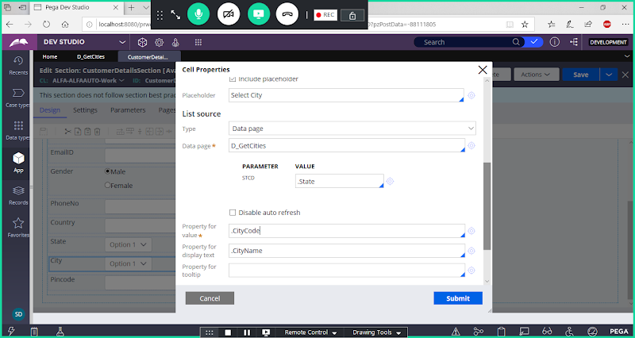

**Submit**

**Save Section**

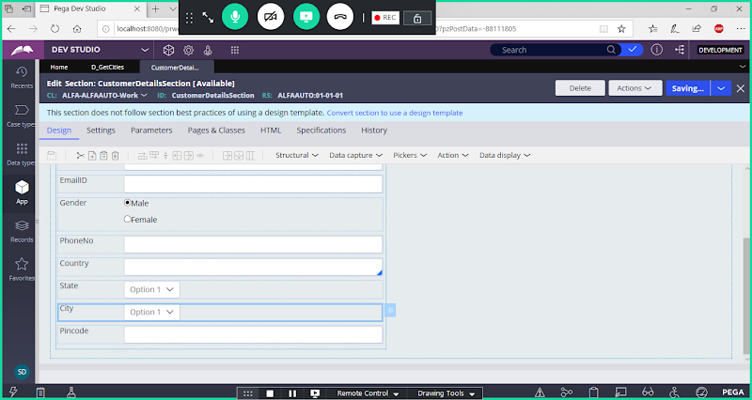

**Now Run Flow & Test**

